Assignment - Data Types | Dimensions | Fields & Charts

# Download the dataset from below link:

* [**Superstore Dataset**](https://drive.google.com/uc?export=download&id=1kr8vrnybJ5S7IQEUXAM2RY9bH1xw5BEm)

# Problem Statement :

* You’ve been provided with a sample ﬁle with some data. Perform the following tasks in the worksheet and submit answers along with a tableau book.
* The sample data contains ***9995*** records with ***21*** columns of information
* The above dataset is sample dataset for superstore

# Metadata :

* *Row ID* => Unique ID for each row.
* *Order ID* => Unique Order ID for each Customer.
* *Order Date* => Order Date of the product.
* *Ship Date* => Shipping Date of the Product.
* *Ship Mode*=> Shipping Mode speciﬁed by the Customer.
* *Customer ID* => Unique ID to identify each Customer.
* *Customer Name* => Name of the Customer.
* *Segment* => The segment where the Customer belongs.
* *Country* => Country of residence of the Customer.
* *City* => City of residence of the Customer.
* *State* => State of residence of the Customer.
* *Postal Code* => Postal Code of every Customer.
* *Region* => Region where the Customer belong.
* *Product ID* => Unique ID of the Product.
* *Category* => Category of the product ordered.
* *Sub-Category* => Sub-Category of the product ordered.
* *Product Name* => Name of the Product
* *Sales* => Sales of the Product.
* *Quantity* => Quantity of the Product.
* *Discount* => Discount provided.
* *Proﬁt* => Proﬁt/Loss incurred.

# Question 1]

By creating charts from above data set answer the following

1. Name the data type of each ﬁeld

Ans.

Integer(#)-

raw id, sales, quantity, discount, profit.

string(ABC)-

order id, customer id,customer name, segment, Region, Product id, category, sub-category, product name,

date-

order date, Ship date,

Geography-

country, city, state, postal code,

1. Categorize the ﬁelds into dimensions and measures

Ans.

dimensions(string)(ABC)-

string(ABC)-

order id, customer id,customer name, segment, Region, Product id, category, sub-category, product name,

measures(integers)(#)-

Integer(#)-

sales, quantity, discount, profit.

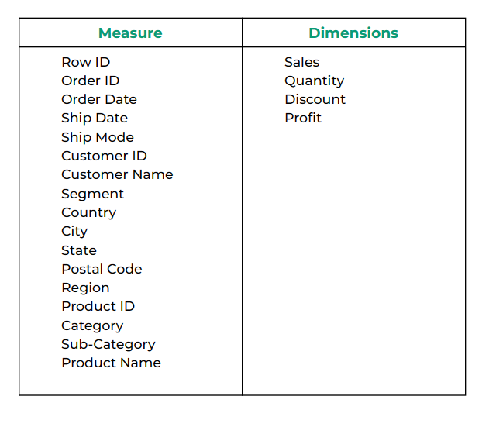

# Question 2]

By creating charts from above data set answer the following

1. Which region has the most sales

Ans.

West region

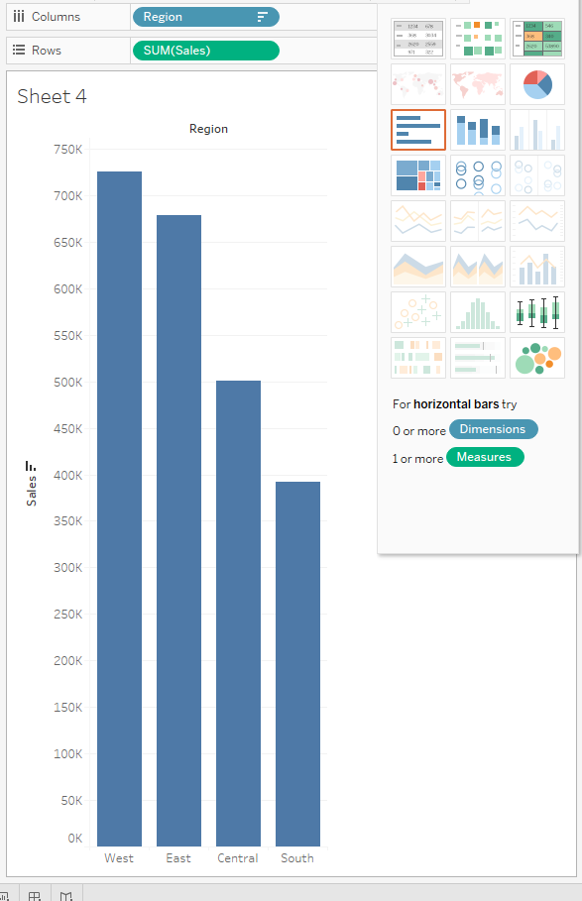

1. In above question, which chart is used and why

Ans.

Bar is used, since it gives the best visuals in addition to ease of comparison.

Suggested to use:

tree map or heatmap to get optimum apace.

1. Which category has maximum and minimum proﬁts with sub category in 2016

Ans.

Max profit-

The technology category has copiers as a sub category.

Min profit-

The furniture category has tables as sub categories.

